Assignment 3: Story Map

**COVID-19’s Effects on Bike Sharing in San Francisco**

The Bay Area’s bike share pilot program was established in August 2013 as Bay Area Bike Share with only a few bikes and stations in operation. The program was later re-launched as Ford GoBike in 2017 and expanded to multiple cities in the Bay Area with over 2,600 bikes. Recently, in June 2019 the bike share program was rebranded to Bay Wheels. Bay Wheels currently operates in San Francisco, Oakland, Berkeley, and San Jose. As of June 2020, Bay Wheels had over 200 bike stations located throughout San Francisco.

Due to the recent coronavirus pandemic, a shelter-in-place order went into effect in San Francisco on March 19th in order to allow social distancing and prevent the spread of the virus. The following report explores the change over time in bike sharing patterns for San Francisco from January 2018 through May 2020. We hope to find changes in bike share usage, travel patterns, and travel locations that occurred after and during the shelter-in-place dates.

**Bike Share Usage**

Bike sharing has gained popularity as a common means of transportation for San Francisco residents. Since its launch date, the bike sharing program has shown an upward trend in the number of bike sharing trips made. The following graph shows bike share usage from January 2018 to May 2020 by the number of trips made per month. As seen, the majority of Bay Wheels trips are in San Francisco accounting for nearly 75% of all Bay Wheels trips. There is less ridership in Oakland, San Jose, and Emeryville.

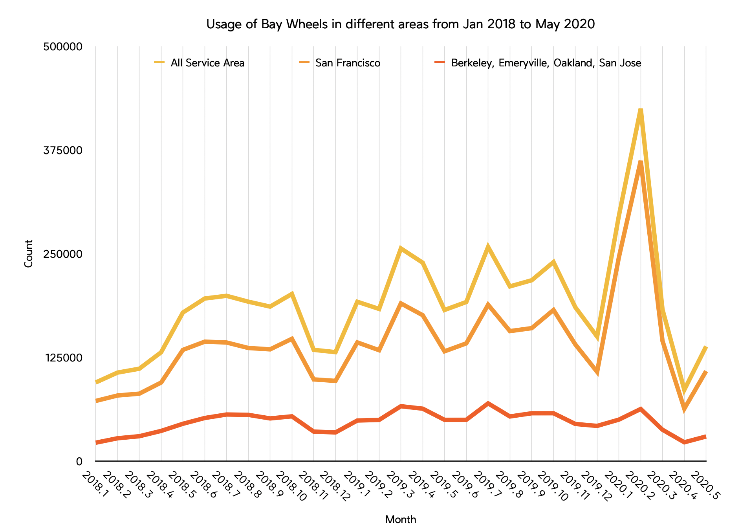

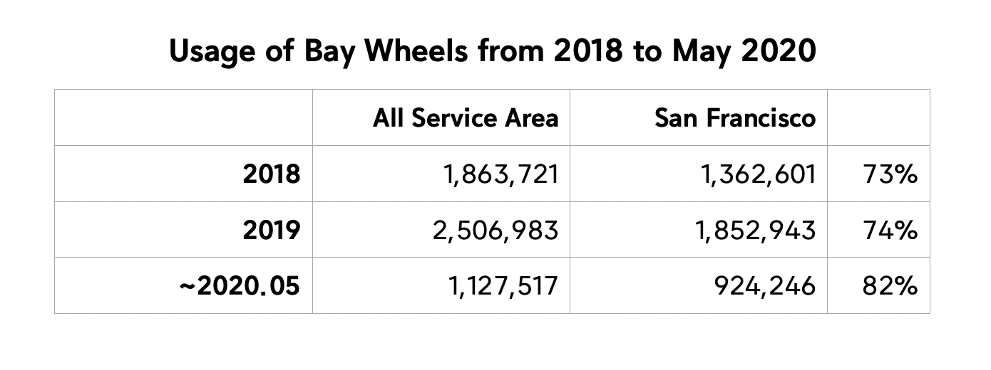

In the month of February 2020, bike share usage increased significantly due to Bay Wheels’ [expansion of dockless electric bikes](https://www.digitaltrends.com/cars/lyft-to-return-its-electric-bikes-to-san-francisco-after-battery-fires/?fbclid=IwAR2yV14Izfy-LjsP35P7exzxPJumNZ7xLS8k17enuQu_XSS6g50aBP3NZdI). Bay Wheels started making these electric bikes available starting in mid-December with hopes of deploying 4,000 bikes throughout the Bay Area in the following months (Mogg, 2019). As seen from the Bay Wheels system data, as of May 2020, these dockless e-bikes have only been made available in San Francisco and San Jose with a much larger number of bikes in San Francisco. Hence, this is why the other service areas did not have a big increase in bike share usage during February 2020 as San Francisco did. However, after the pandemic and shelter-in-place orders went into effect in San Francisco and Alameda County, all areas in which Bay Wheels operates decreased in ridership with a significant decrease in rides for the month of April 2020.

**Travel Patterns**

Some of the travel patterns that are tracked by Bay Wheels include the location of trips, the time of day for trips, the type of rider (casual or member), and the duration of trips. The following visualizations will show those patterns and how they compare before and after the shelter-in-place.

Trip Locations

After the Bay Wheels program gained popularity, more bike sharing stations were opened to operate. In addition, Bay Wheels is continuing to expand its services to more stations and has several proposed sites to do so. Recently with Bay Wheels’ introduction of dockless electric bikes, users can now pick up a bike at not just a station but rather throughout different locations in San Francisco. The following map shows the start locations for trips made in February 2020, before the shelter-in-place order went into effect in San Francisco and the start locations for trips made in April 2020, after the shelter-in-place order. These maps show the effectiveness of having dockless bikes since it increases accessibility to areas that lack Bay Wheels stations.

It is evident that the locations of trips made in April 2020 compared to February 2020 are significantly less. The concentration of trips that are made in the northeast area of San Francisco decreased in April 2020, and instead there was more scatter towards other areas like the southwest region. This is probably due to less people having to commute to work in areas like the Financial District and South of Market. Meanwhile, as seen earlier people are biking during afternoon hours probably for leisure and are instead using Bay Wheels in residential areas like the southwest region of San Francisco. However, due to the Bay Wheels stations not being evenly distributed throughout San Francisco and having less people bike sharing, this means that the availability of dockless bikes near certain areas that do not have a station could have possibly become a problem after the shelter-in-place order.

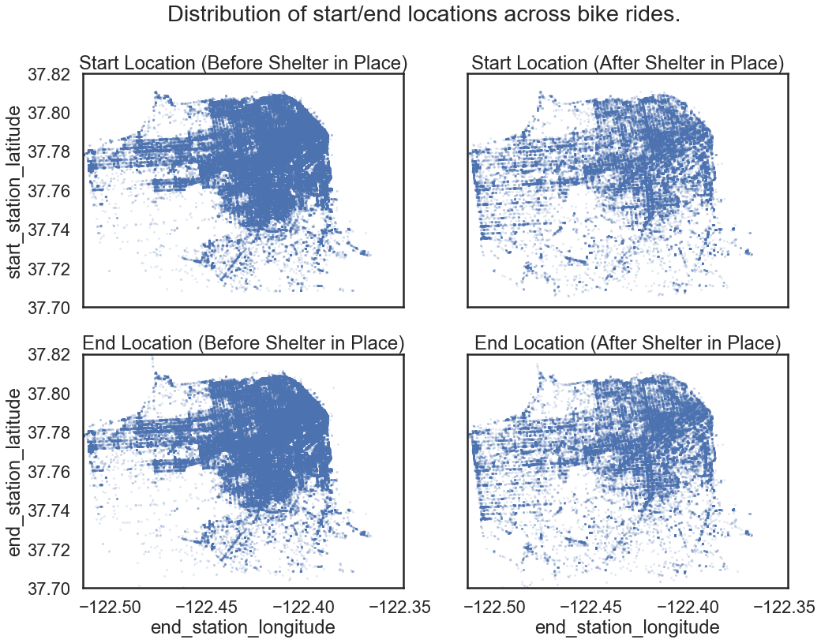

Time of Day

The chart below shows that bike sharing is most common during 7am to 9am and 4pm to 6pm based on data from January 2018 through May 2020. This time period coincides with San Francisco's work rush hours and perhaps people use this mode of transportation to commute to and from work.

After the shelter-in-place order went into effect in mid-March, a lot of jobs closed and some employees started working from home. By taking a closer look at bike sharing trips made during the months following the shelter-in-place order, we can see that the most common times for bike sharing trips shifted. The month of March still followed a similar travel pattern as the average popular times, partially due to the order being placed in effect halfway through the month. However, the months of April and May show very different patterns. The biggest difference is that the number of trips made in the mornings decreased significantly during April and May. In addition, trips during the afternoon increased, which is a riding time that wasn’t popular before the shelter-in-place order. The increase in afternoon trips can be due to people starting to bike leisurely throughout their neighborhood.

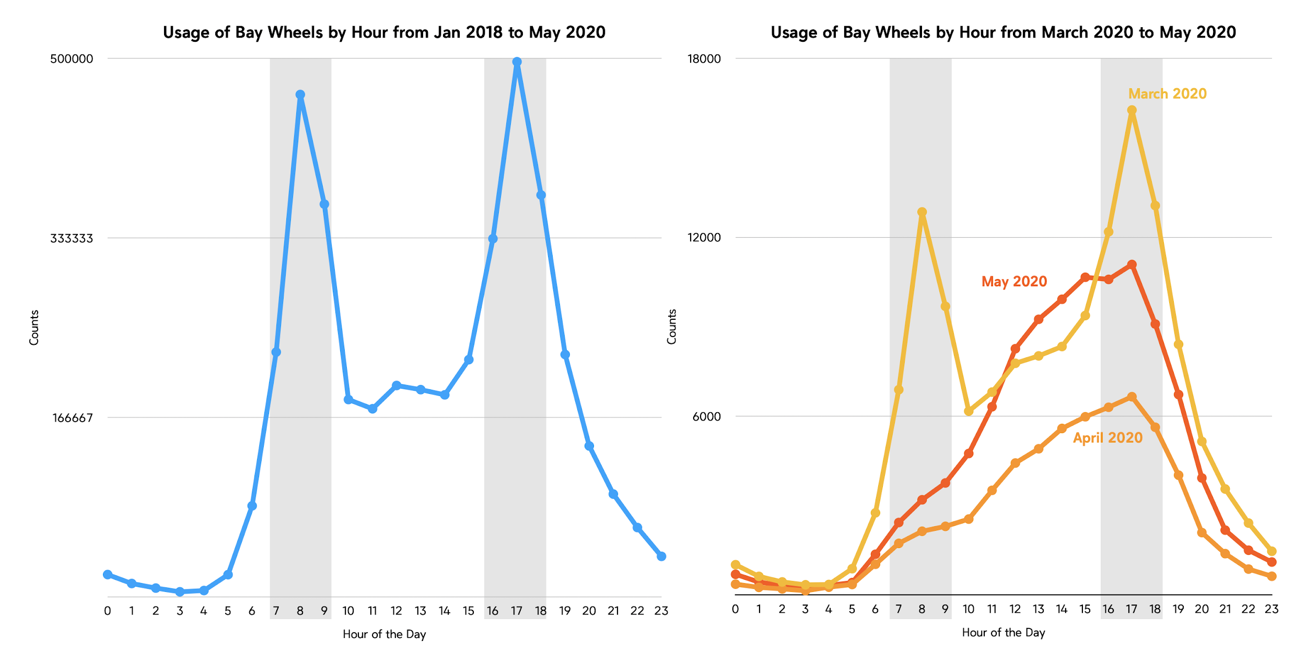

Rider Type

Bay Wheels tracks whether the rider is a casual rider or a member for every bike sharing trip made. This travel pattern also changed slightly after the shelter-in-place order went into effect. The number of members using the service has always been much higher than the number of casual riders. As mentioned before dockless e-bikes were expanded starting in mid-December, which caused an increase in both the members and casual riders. In fact, the number of casual riders rose to the highest number it has ever been.

However, after the shelter-in-place order, the number of members and casual riders both decreased with trips made by members dropping even lower than the trips made by casual riders. This is most likely due to people no longer commuting to work, which is most likely the same people that have memberships for the Bay Wheels service. Meanwhile, casual ridership increased in April and May due to people riding leisurely instead of using the service solely to commute to and from work.

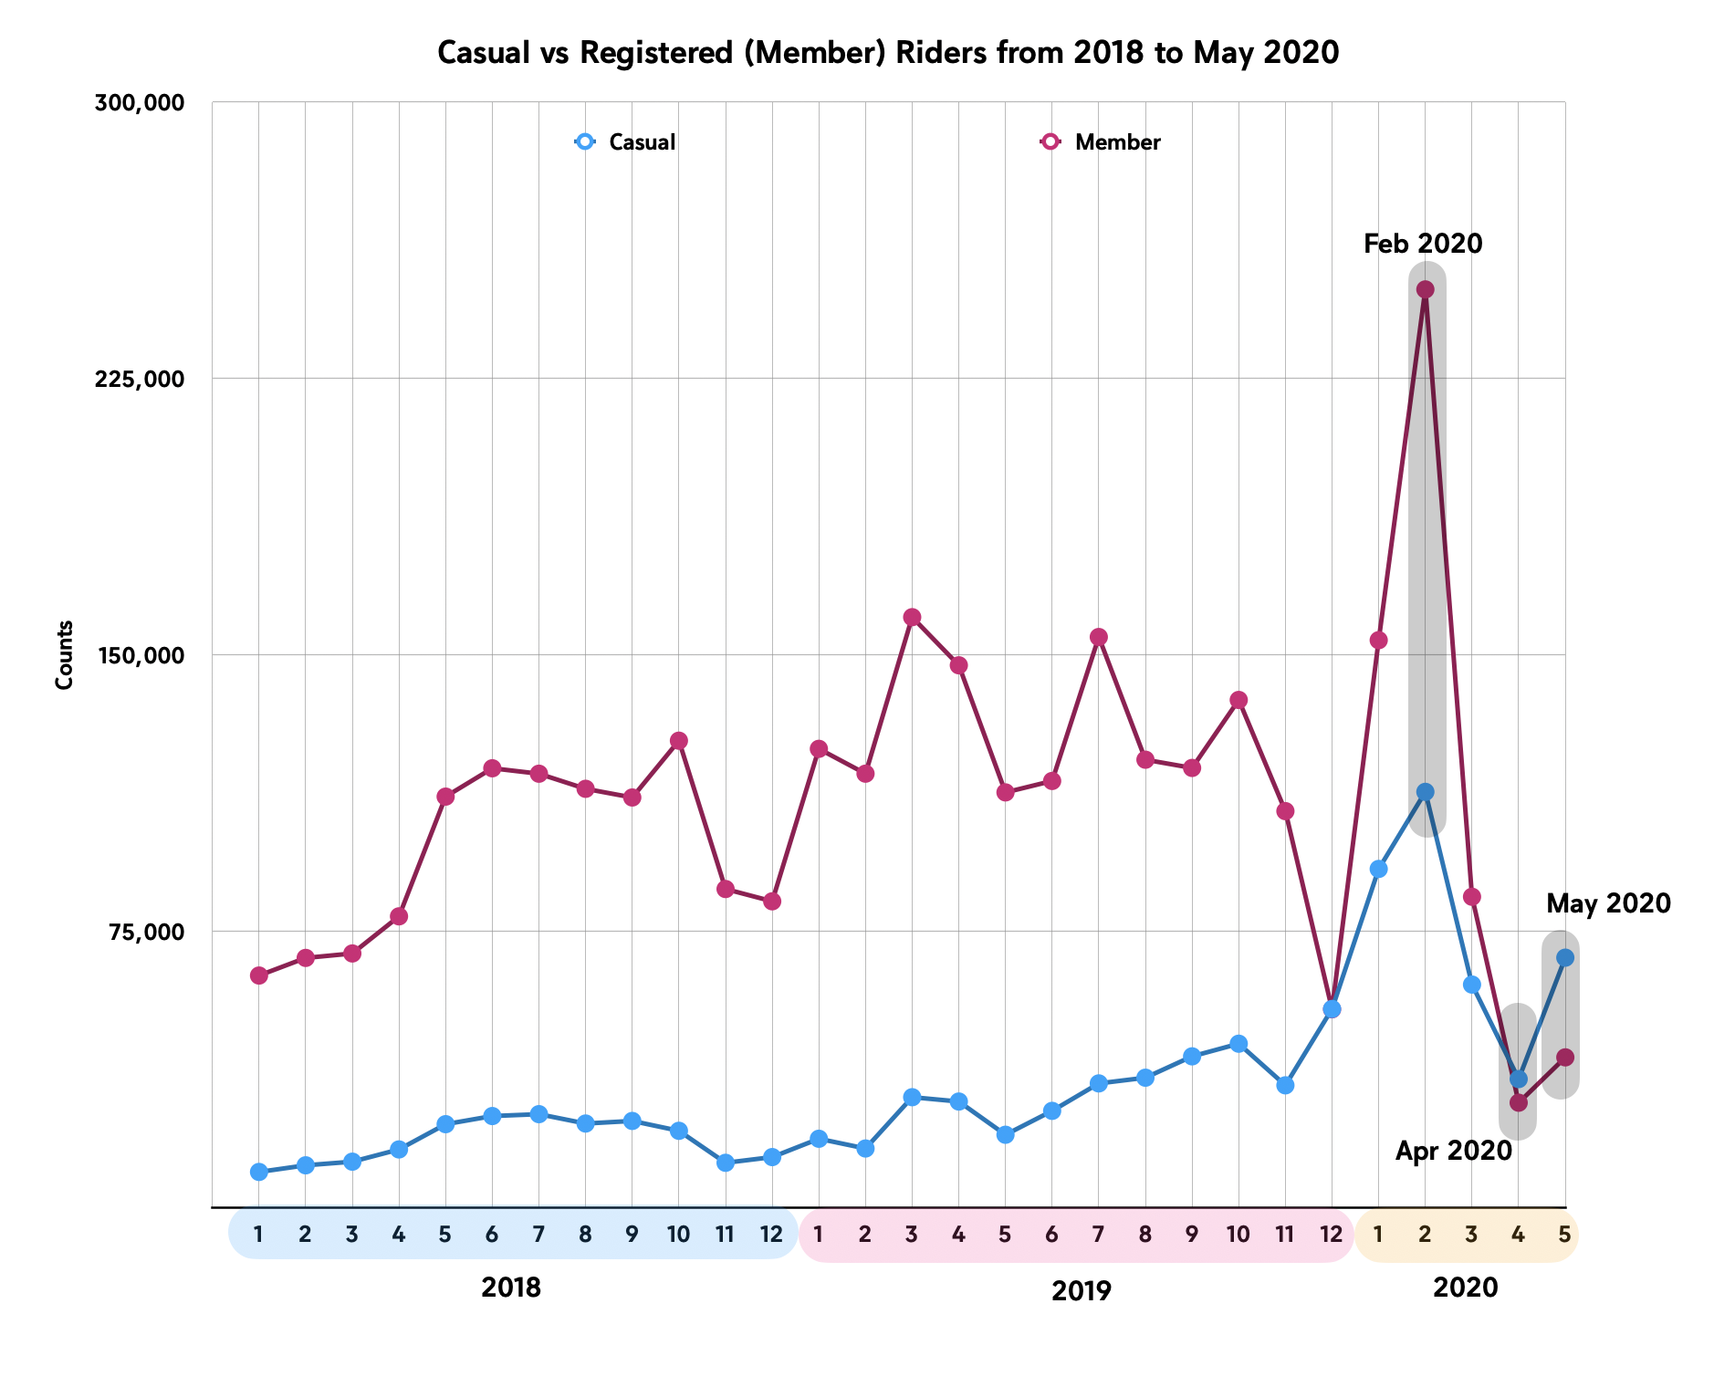

The maps below show a spatial analysis of the rider types for the Bay Wheels service. The first map shows the users for the month of February 2020, before the shelter-in-place. The map shows that the majority of riders are members and most of the rides are being made in the downtown San Francisco area.

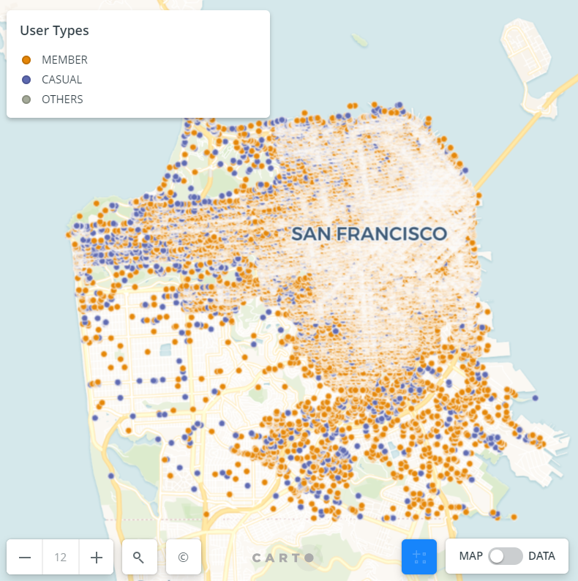

This second map shows the distribution of Bay Wheels rider types for the month of April 2020, after the shelter-in-place. From this map and its distribution, we can see that casual riders were more common than members. Moreover, we can also see that the number of casual riders in the impacted area of downtown San Francisco increased from February to April.

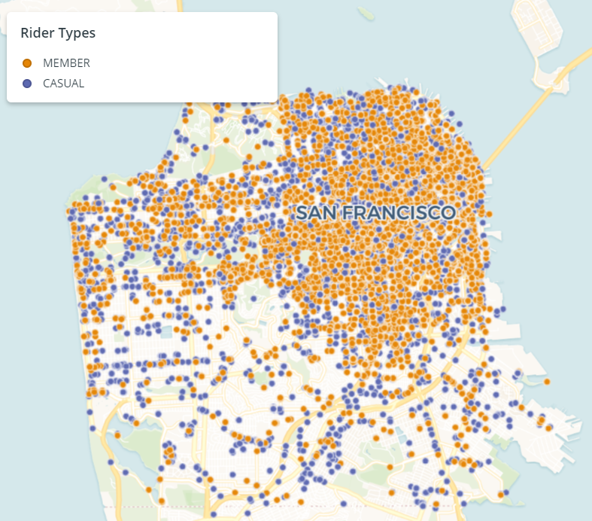

Trip Duration

The average trip duration is another travel pattern that showed differences between data from before and after the shelter-in-place began. After the shelter-in-place began, the bike share's duration changed from an average of 808 seconds (13.5 minutes) in February to an average of 1123 seconds (18.72 minutes) after shelter-in-place. Although the increase in trip duration isn’t significant, this increase could be due to more casual riders using the service perhaps to ride leisurely as opposed to member’s riding on a time constraint to get to work in the mornings.

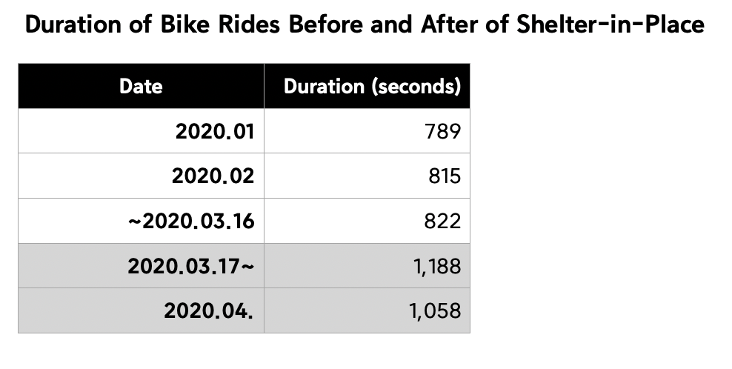

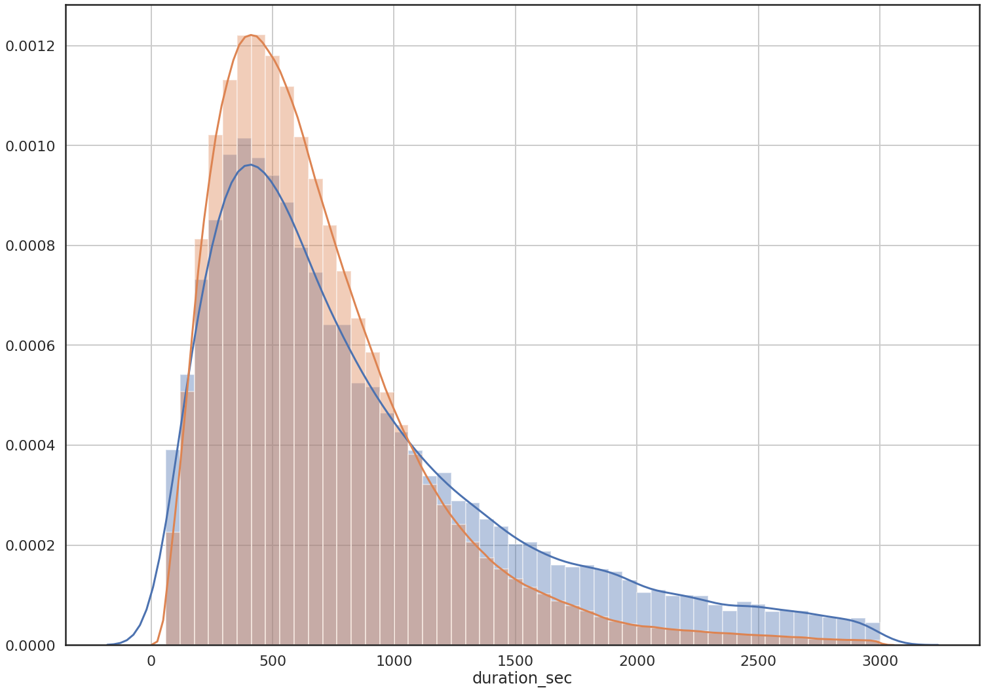

The following maps show a spatial analysis of the duration time for trips made before and after the shelter-in-place. The trips in the downtown San Francisco region, which has more bike stations, has a lower trip duration than other places. The western region has fewer bike stations and has a relatively longer trip duration. In other words, the number of bike stations in an area is inversely proportional to the duration of users using share bikes.

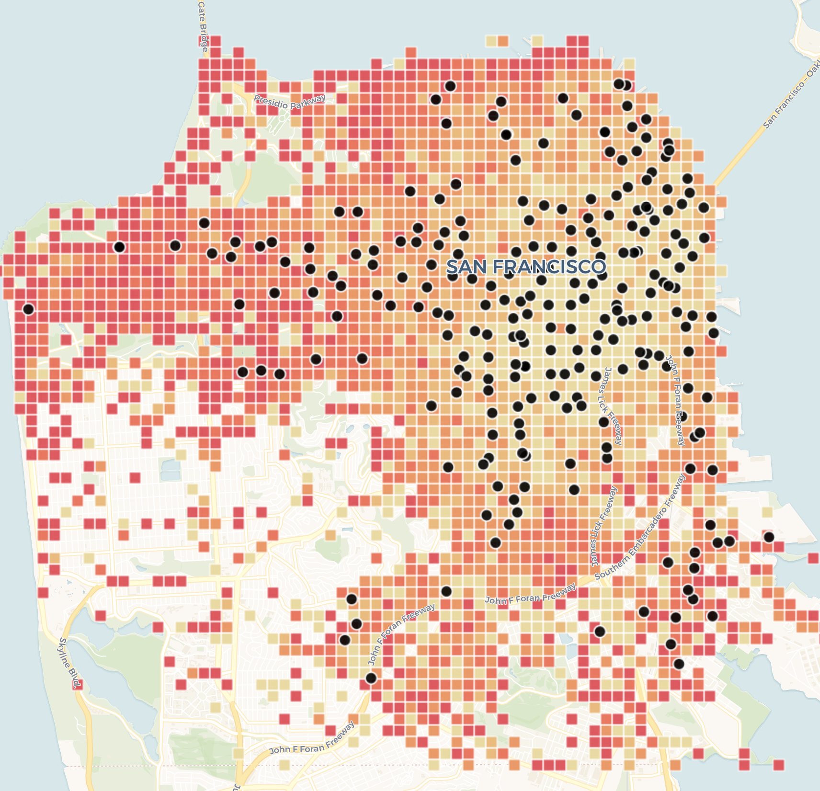

After the shelter-in-place announcement, the number of bike share usage increased significantly in the southwestern region without a bike station, and the duration of these users was higher than in the denser areas with bike stations. This situation also caused a problem, because Bay Wheels has put e-bike on the market, and e-bike needs to be charged at the bike station. The lack of bike stations in the southwest means that a large number of unusable e-bikes will be placed on the streets, and this situation will greatly reduce the mobility of e-bike. On the other hand, Bay Wheels needs to send people to collect these powerless e-bikes, which will also increase the operating costs of Bay Wheels.

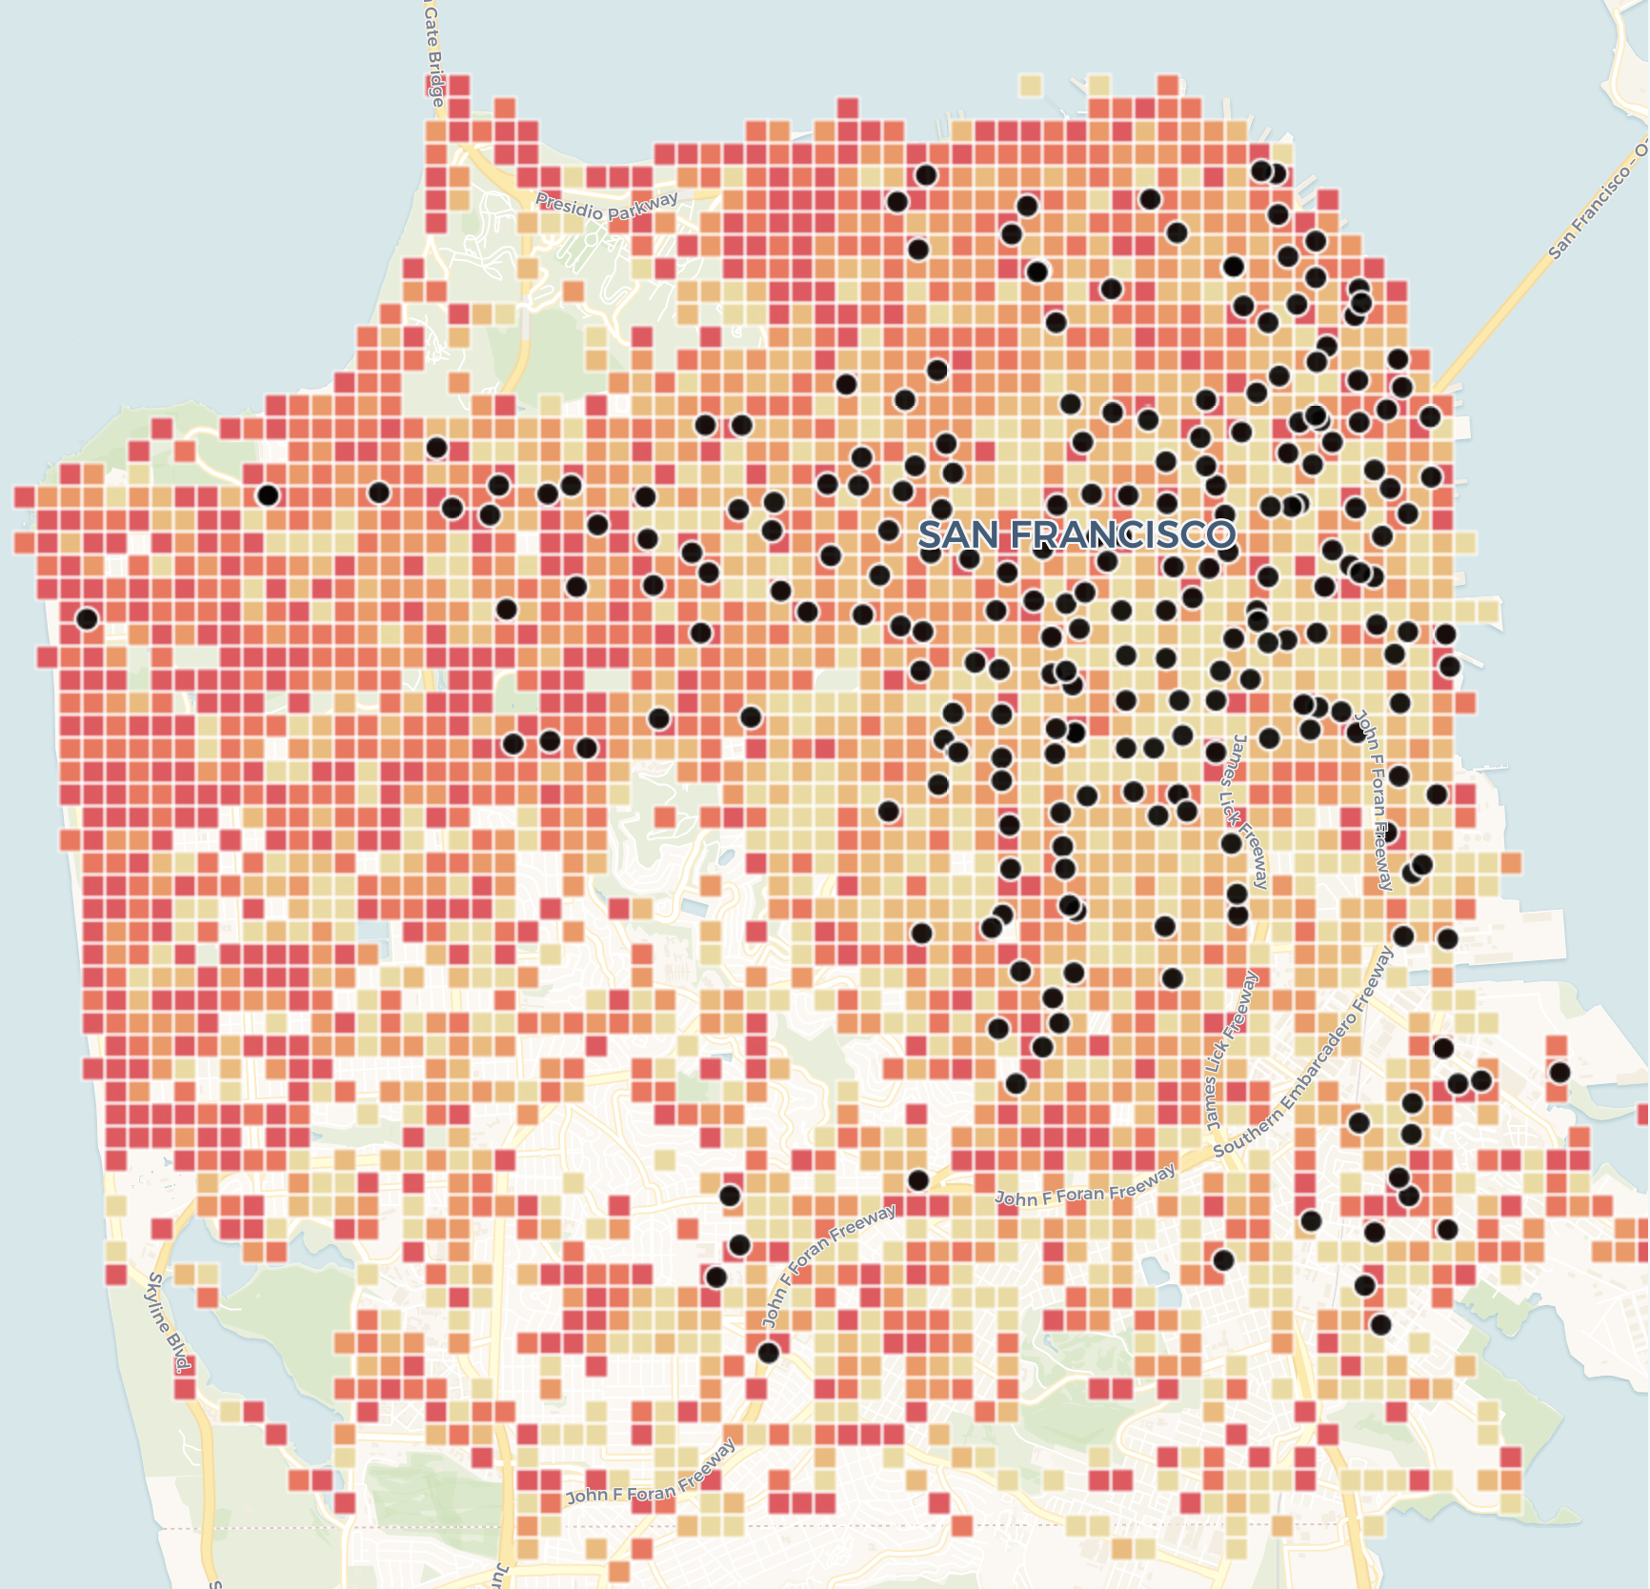

As we can see in the following map with green and red points, the red points are the starting location and the green points are the destination. We can find that bike share users in the northwest region mainly use bike share to go to the northeast region, which is the center of San Francisco. Since a bike share cannot be used by two or more people at the same time, users are unlikely to use bike share as a tool for family travel, and a more likely explanation is that bike share is used by users as mass transit to work. Therefore, when the usage in the east region increases, this means that more long-distance travelers appear, which leads to an increase in the duration. Another reason might be street closure in some areas due to COVID-19. The closure of the street makes it less possible for users to drive to some areas,therefore, users might choose to use bike share to go to their destination. This part will be further discussed later.

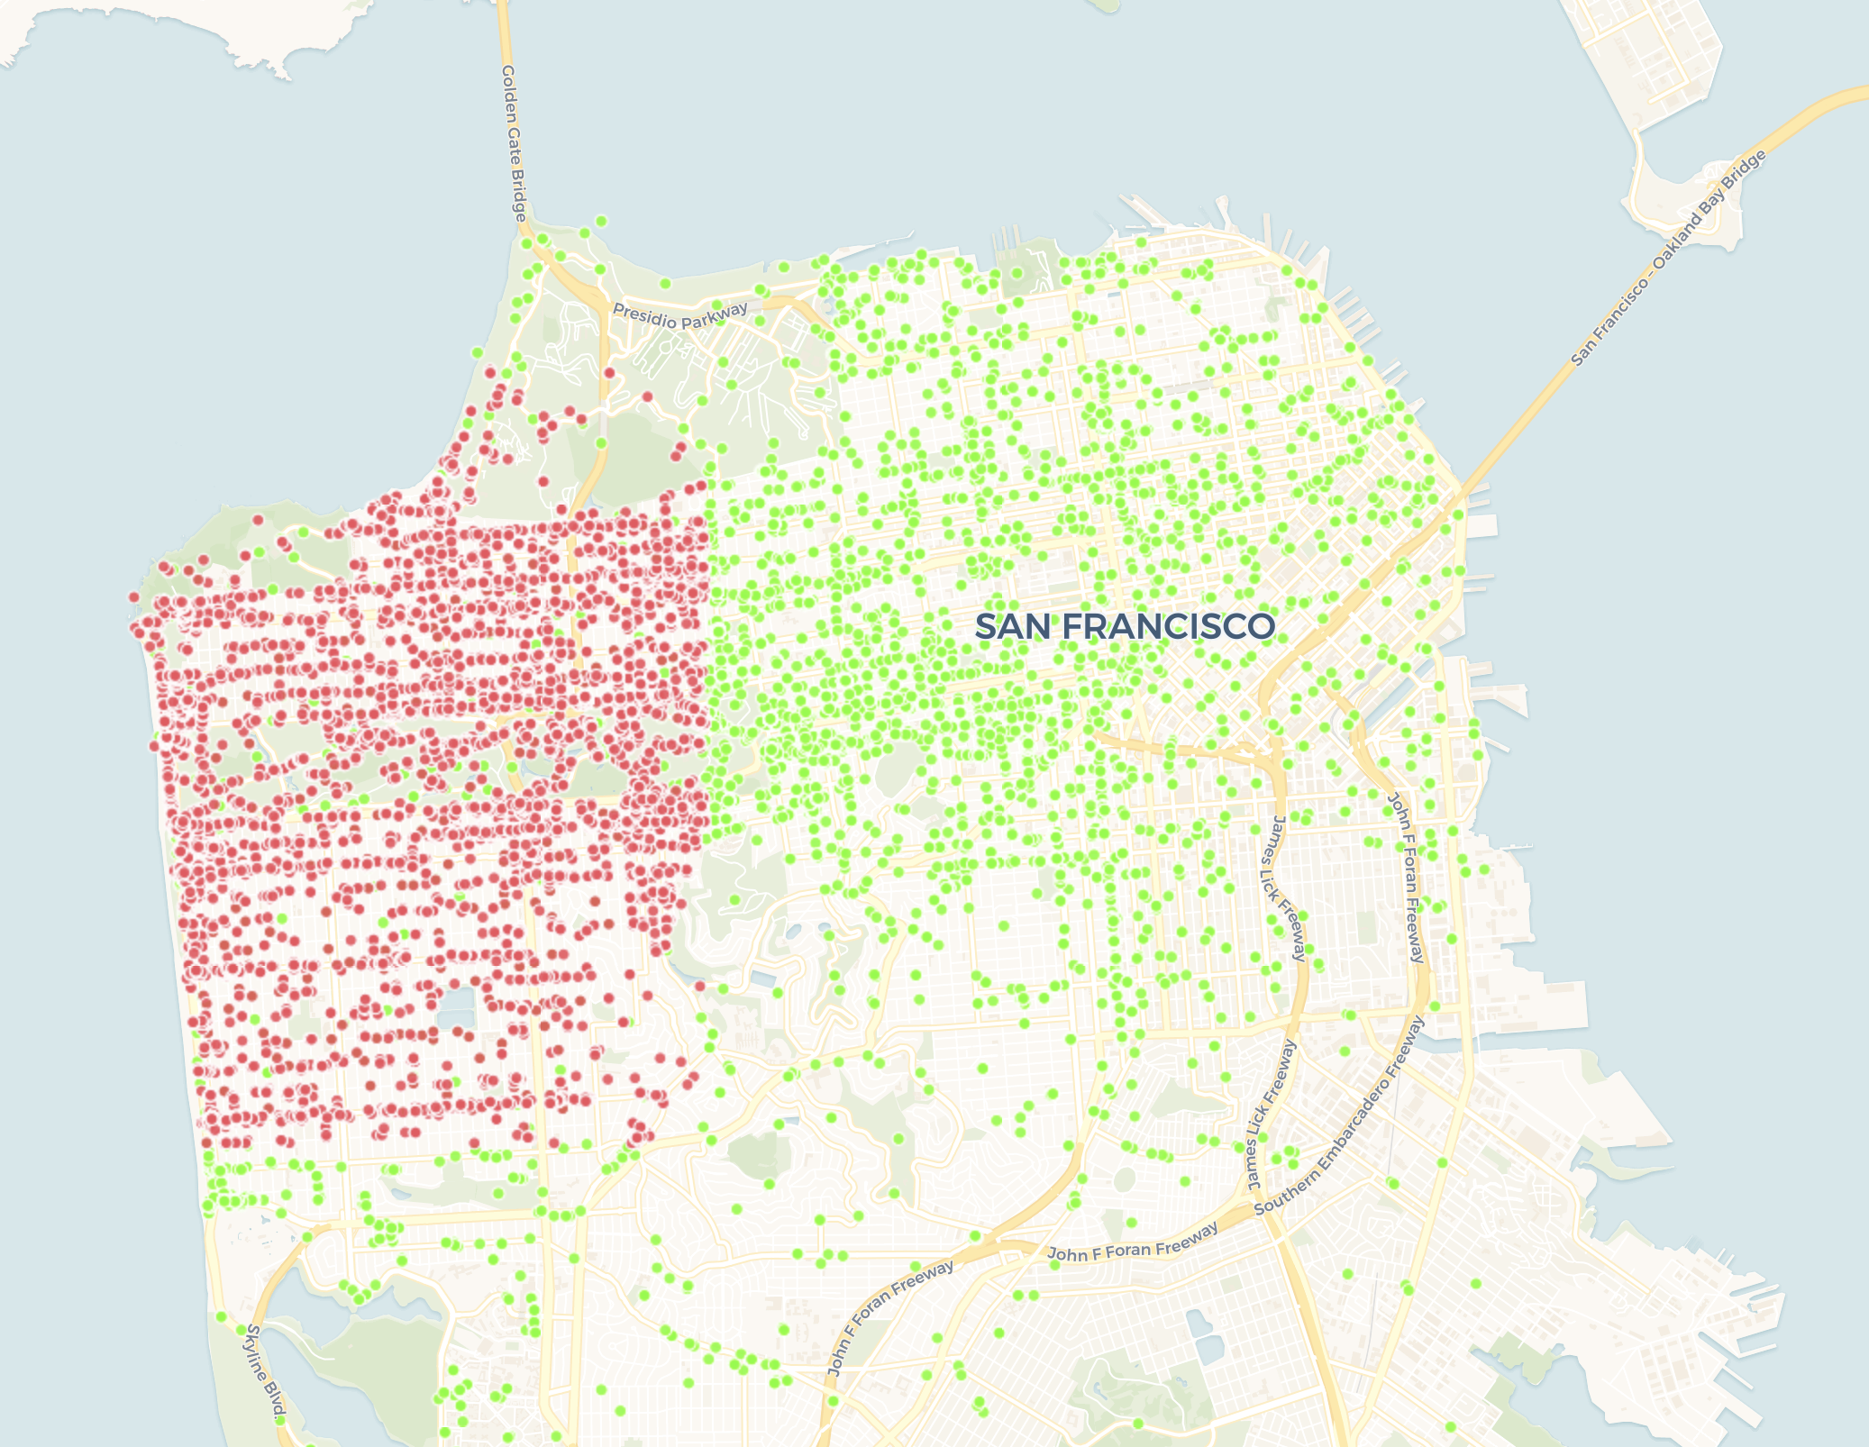

If we focus more on the southwest region, we can find that although there is no bike station in the southwest region, the distribution of bike share usage is still similar to the entire east region. The population in this area is roughly 100,000, but there is no BART station. Therefore, the only options for people to travel are car, bus, and bike. After the announcement of shelter-in-place, public transportation such as buses and trains reduced in San Francisco. On the other hand, public transportation makes it difficult for people to follow the rules of social distance. Under these circumstances, bike share has become the best choice for solo travel.

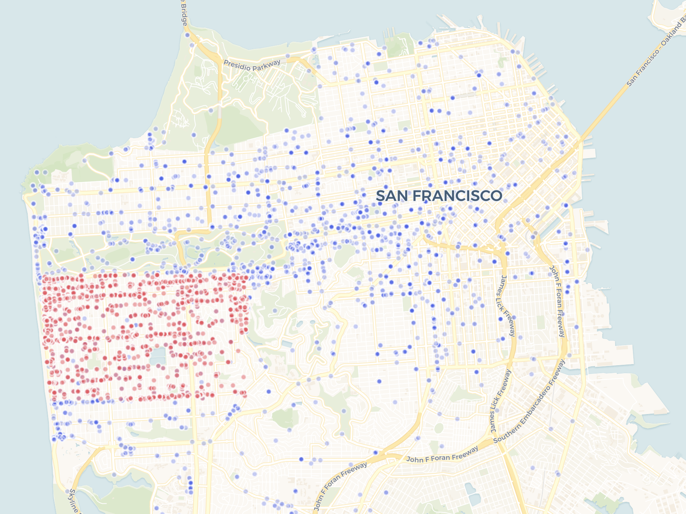

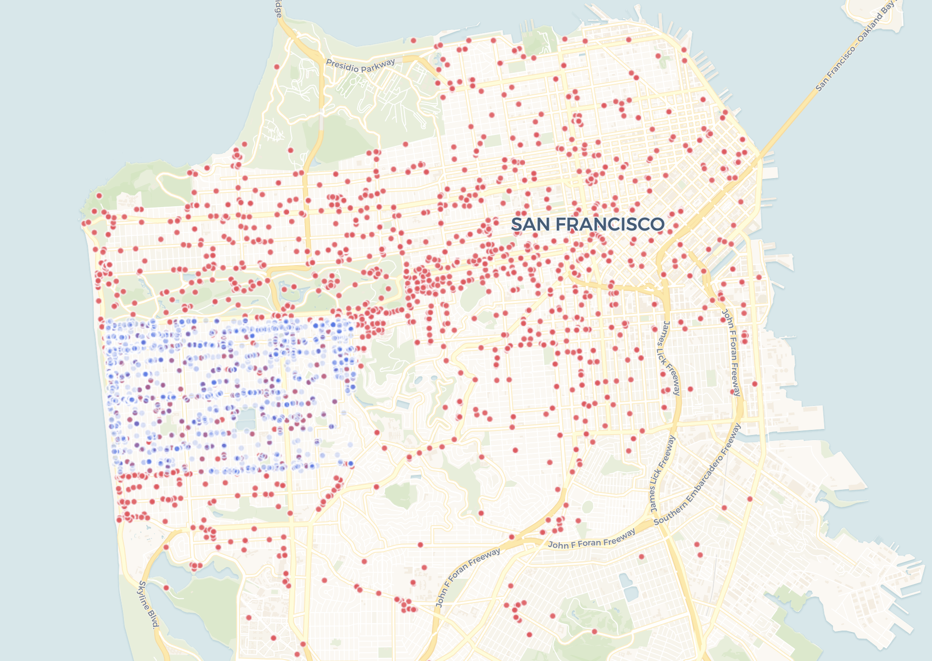

During shelter in place. Red (start) -> Blue (end)

**Relationship between COVID-19 and Bike Sharing**

The following map shows the confirmed coronavirus cases for San Francisco by census tract. The most popular stations in April 2020 are also shown in the map. As we can see from the map, COVID-19 has had a greater impact on the east of San Francisco with most of the cases concentrated in the southeast region. Meanwhile, the most popular stations are not located in that region.

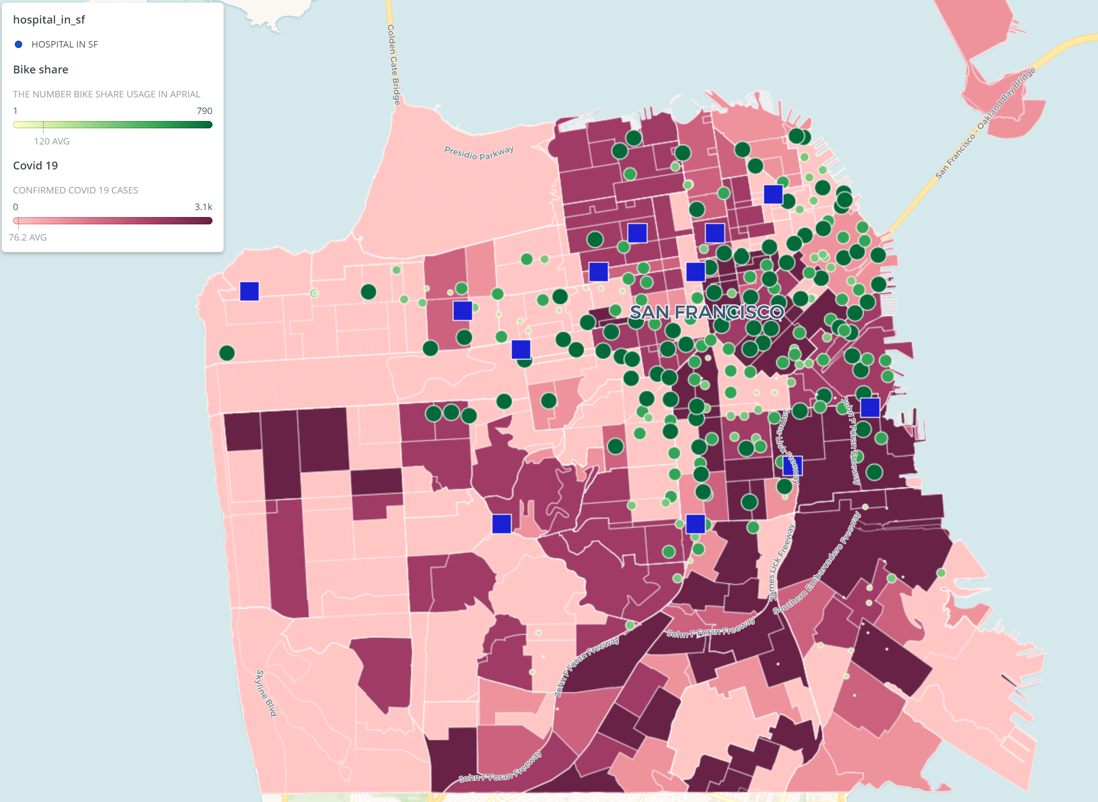

In order to find whether there is a correlation between bike sharing and COVID-19 cases, we combined data of the rate of confirmed cases rate by population for neighborhoods with the rate of bike share trips in that neighborhood over the usage of all of San Francisco. We found that the correlation between these two is 0.23. This result does not show that COVID-19 is significantly related to the usage of bike share. The three neighborhoods that use bike sharing the most are Mission, South of Market, and Financial District. The usage of these three neighborhoods accounted for 38.99% of the total usage in San Francisco. The percentage of COVID-19 confirmed cases in these neighborhoods accounted for only 24.19% of the total cases in San Francisco. The highest confirmed case per rate among all neighborhoods occurred in Japantown with 1.1%, but the usage of bike share in this neighborhood only accounted for 0.4% of the total usage.

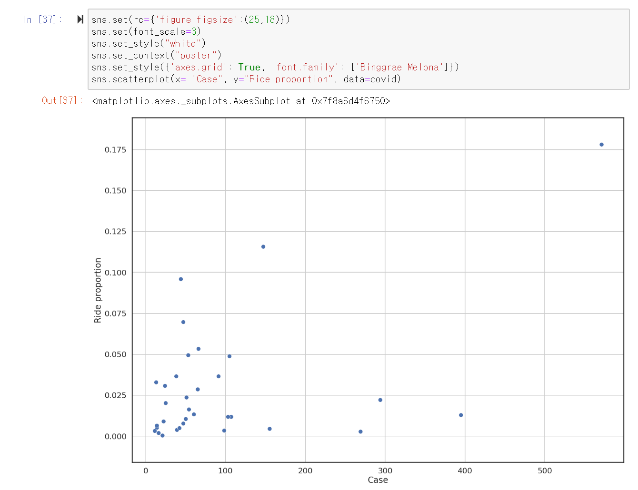

Bike share usage is mainly concentrated in places with high population density in San Francisco. These places include Union Square, Chinatown, Civic Center, and other San Francisco landmarks. The high population density may be the reason for the number of confirmed cases. In order to confirm our point of view, we compared the population with confirmed cases of the neighborhood and found that their correlation was 0.55. Next, we compare the population and the number of bike share usage of the top 10 places for bike share usage, and the correlation between these two is 0.61. In the previous part, we found out that the correlation between bike share usage rate and COVID-19 confirmed case rate is 0.23. Combining these three results, we can find that population size has a certain correlation with confirmed cases and usage of bike share, but the correlation between confirmed cases and usage of bike share is relatively smaller, which shows that the two do not affect each other very much.

The Future of Bay Wheels During COVID-19

After the shelter-in-place order went into effect, transportation agencies such as BART [reduced their service hours](https://www.bart.gov/news/articles/2020/news20200319) in response to lower rates in ridership. One reason for the decrease in ridership can be attributed to less people commuting to work, but another factor can also be that [people are uncomfortable](https://sanfrancisco.cbslocal.com/2020/06/22/bart-officials-weigh-how-to-boost-ridership-as-covid-19-restrictions-reduced/) sitting in an enclosed train. Even though BART is promoting that trains are being cleaned and sanitized, the ridership has decreased by over 90% during shelter-in-place.

While services like BART are seeing a decline in ridership during the pandemic, other modes of transportation like bike sharing and electric scooters might become an alternative for people since it is easier to practice social distancing. Moreover, the map below shows that Bay Wheels has stations located at each of the BART stations in San Francisco enabling people to use Bay Wheels rather than BART. Moreover, the expansion of dockless electric bikes can also help with increasing the use of bike sharing over other modes of transportation to help practice social distancing.

The map below also shows the proposed Bay Wheels stations that will begin operating in the near future. The SFMTA bikeway network in San Francisco is shown in the map as well, and depicts that most of the stations are located along the bikeway network. In the future, Bay Wheels should consider opening stations in the areas of the bikeway network that don’t have a station such as the west side of San Francisco. From the previous maps, we have seen that this same area is starting to be used by bike share riders on dockless bikes. If stations opened up in these areas, it would make bike sharing more accessible.

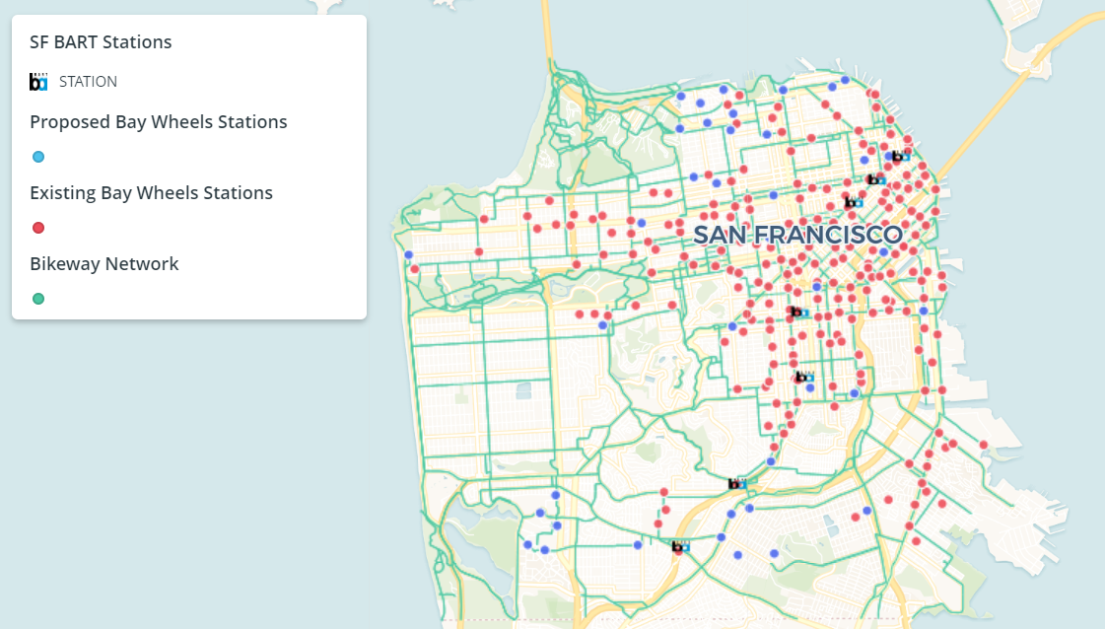

Recently, the SFMTA launched the Slow Streets program in hopes to allow residents of San Francisco public space to practice social distancing. The visual below shows the map of where these streets are located. These slow streets have limited traffic and encourage walking and biking. As seen below, SFMTA is planning to expand the Slow Streets program to streets in the same areas where Bay Wheels bike sharing has been increasing as seen in previous maps.

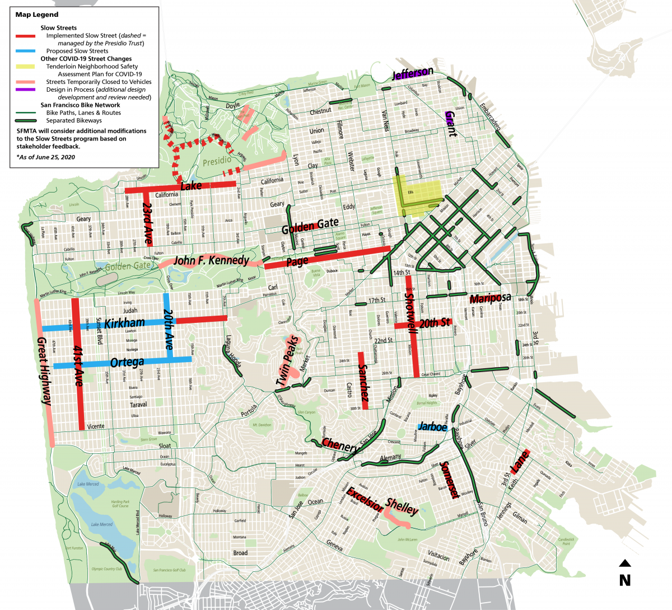

With the help of the Slow Streets program, San Francisco residents are being encouraged to use biking since more public space is being made available for it. This is due to biking enabling people to follow the social distancing rules. This can lead to Bay Wheels having an increase in ridership moving forward, even during the coronavirus pandemic.

Conclusion

In mid-December, Bay Wheels stated their plan to help expand its service with the launching of dockless electric bikes. Due to COVID-19, the rapid increase that these e-bikes brought in ridership soon dropped after reaching its peak in February. Several other travel patterns for Bay Wheels shifted after the shelter-in-place order went into effect. The effects include changes in the number of trips, the location of trips, the rider types, the duration of trips, and the time trips are made. All of these changes began once the shelter-in-place and social distancing started. The overall key findings include: bike stations are excessively concentrated in the middle of San Francisco, the number of bike stations in a region is inversely proportional to bike share duration, the lack of bike stations in the west region will cause a large number of e-bikes to be unserviceable because they cannot be charged.

Although COVID-19 has affected Bay Wheels ridership, the future for Bay Wheels and traveling on bikes seems bright. The shelter-in-place has encouraged biking through programs like SFMTA’s Slow Streets. Moreover, social distancing is much easier to follow by using bike sharing to get around rather than other modes of transportation like buses or trains. As seen in the data, the ridership for Bay Wheels is slowly starting to increase again and may continue to do so if there’s continual support from the City and residents to follow social distancing rules.

A city's bike system is often related to the development of the city, and this outbreak is a challenge to the city of San Francisco. If San Francisco does not have a bike system, the impact of this epidemic on people will be even stronger. The government may close more streets to prevent people from driving, and many people may not be able to go to the supermarket to buy their necessities. In conclusion, we have a few suggestions for Bat Wheels. First, try to average the number of bike stations in each region as much as possible, which can improve the mobility of bike share. Second, try to lower the usage price at noon on weekdays and weekends to increase the usage rate of bike share during these periods. Third, give casuals free trial to increase the number of the membership of bike share. And lastly, add more bike stations to the bart station in the south to increase the utility of bike share. Although COVID-19 damages the strategic layout of Bay Wheels, but crisis is also a chance. If Bay Wheel can seize this opportunity, bike share's market share may increase significantly.